Ruth Ann Dean Memorial Birdathon 2017

The Potomac Valley Audubon Society will hold a Birdathon the month of May.
The event is being named in honor of Ruth Ann Dean, who was a founding member and ardent lifelong supporter of PVAS, a Board member in the early years, and an avid birdwatcher.
The birdathon is a fun event that contributes to migratory bird surveys worldwide and also helps PVAS raise money for ongoing bird conservation initiatives. Teams will compete to identify the highest numbers of bird species they find in Jefferson, Berkeley, Morgan and Washington counties and on the Potomac River bordering those counties within any 24-consecutive-hour-period during the month of May.

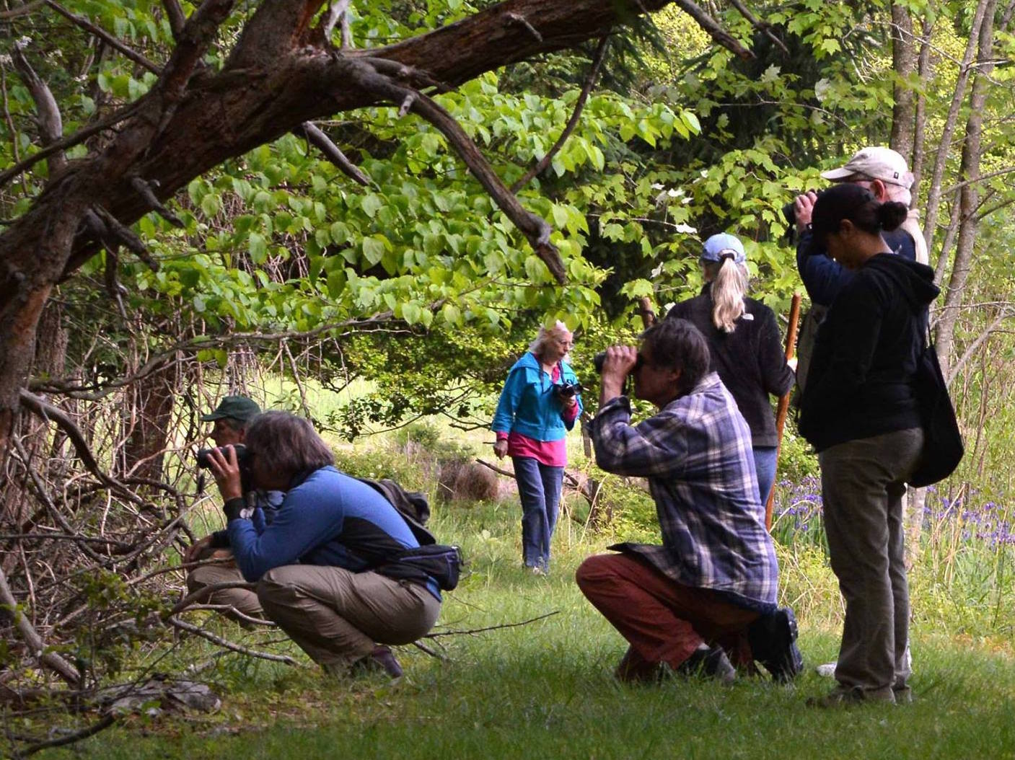
Besides the fun, the valuable observations obtained by birdwatchers contributes to a large citizen science effort. The species’ list collected by birdwatchers’ during birdathon provides crucial information to track bird migration trends. This data is compared with that from subsequent-year Birdathons. Collectively, the information tells us about our local bird populations, and also contributes to global bird databases used by researchers and scientists.
Participants can choose to form their own teams, decide their team names and select their own leaders. If you don’t have a team, we will help you find one.
Another option is to participate individually in a "Big Sit," in which individuals choose a 17-foot diameter circle or their porch and identify all birds they see from that area within a 24-consecutive-hour-period.
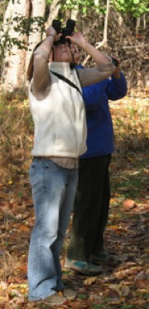
Prizes will be given to teams for the most species counted, the most uncommon species, the most species identified by a youth team or team consisting of new birders, and the best team name. A "Sitting Duck" prize will also be given for the winner of the Big Sit. The winners in all categories will be announced in Valley Views, the PVAS newsletter and online.
There is no entrance fee and registration is easy. Teams must consist of 2-5 participants (unless a person registers for the Big Sit). All you have to do is get together with friends and form a team. Or you could make this a family event and enter as a family team. Identify your team members, choose a leader, select a team name and decide whether your team will be competing in one of the special categories, such as youth or new birder teams.
Once teams are formed they ask for pledges ($1, $2, $5 or more) for each species of bird they observe during their 24-hour birdathon period. These pledges entice participants’ and also help raise money for PVAS bird conservation programs. This year the birdathon funds will go toward building habitat for Chimney Swift through our “Raise the Roost” Project.
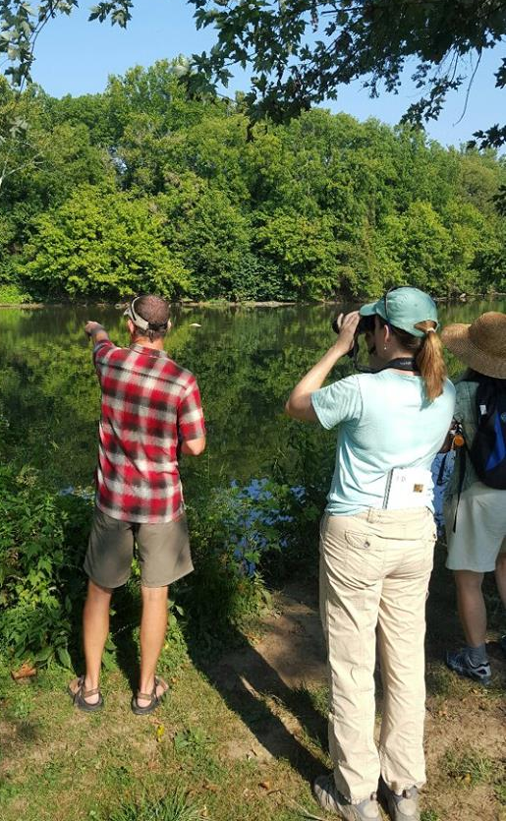
Teams and individual "Big Sit" participants should
notify Bridget Tinsley, the Birdathon coordinator,
at 304-261-6016 or bridget@potomacaudubon.org, telling how they plan to participate.
The deadline for registration is April 22, 2017. Teams and "Big Sit" participants will be sent a species list, simple rules for the competition, and any other instructions needed for the event.
Please join us for this fun event!

